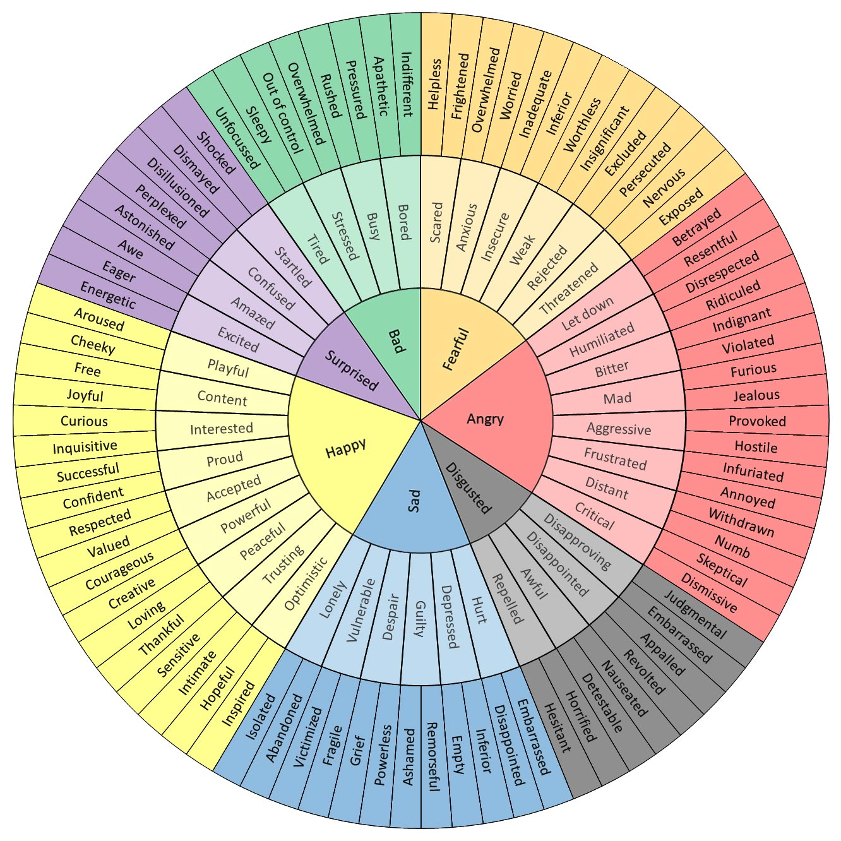
https://imgur.com/a/CkxQC
EMOTION WHEEL

